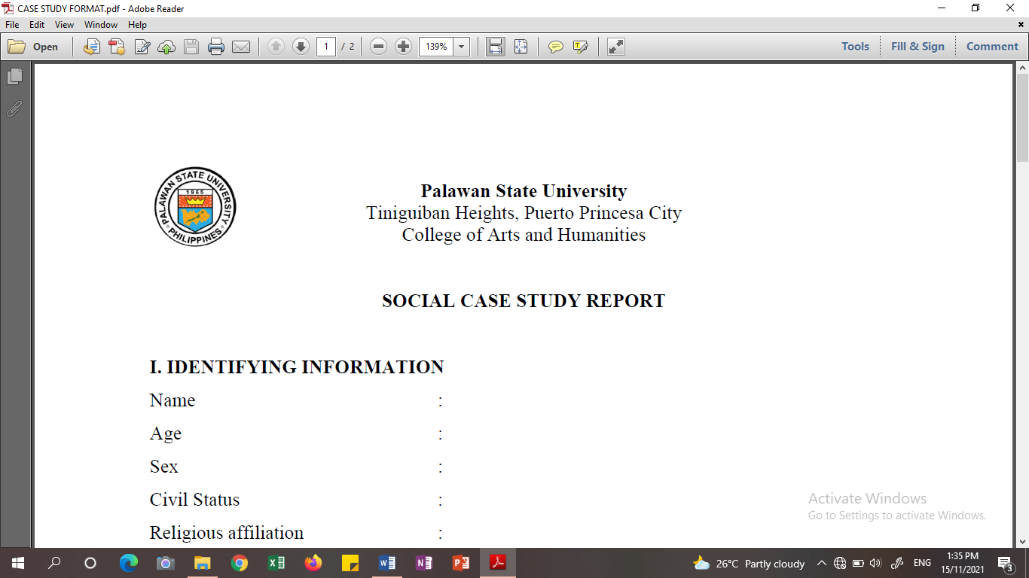Palawan State University
College of Arts and Humanities
Bachelor of Science in Social Work Program
Tiniguiban Heights, Puerto Princesa City

SOCIAL CASE STUDY REPORT
Date: December 15, 2023

- IDENTIFYING INFORMATION

Name : Mildred Jaranilla Badajos
Age : 49
Sex : Female
Civil Status : Single
Religious affiliation : Catholic
Date of Birth : February 10, 1974
Place of Birth : Cuyo, Palawan
Highest Educational Attainment : College Graduate (Bachelor of Science in Business Administration)
Occupation : Tailor
Monthly Income : ₱5,000.00
Present address : Purok Imelda, Brgy. Sta. Monica, Puerto
Princesa City
Home address : Purok Imelda, Brgy. Sta. Monica, Puerto
Princesa City

- FAMILY COMPOSITION
Name | Relationship to client | Age | Birthday | Educational | Occupation | Civil Status | Monthly Income
Victoria Jaranilla Badajos | Mother | 76 | February 23, 1947 | Grade 4 | N/A | Married | N/A
Alfonso Aquias Badajos | Father | 83 | November 11, 1940 | Grade 1 | N/A | Married | N/A
Mike Boy Badajos Denzo | Son | 14 | June 23, 2009 | Grade 9 | Student | Single | N/A

- PRESENTING PROBLEM
Financial problem:
Mildred does not have a stable and sustainable livelihood and source of income and only depends on her small sari-sari store and tailoring business as the source of her income. She also stated that money is her main problem because her everyday income is not enough to sustain the family’s needs.

- BACKGROUND INFORMATION
A. The Client
Mildred Jaranilla Badajos is a 49-year old female, from Purok Imelda, Barangay Sta. Monica. Around 52kg in weight and 5’1 in height. Healthy, and with no disability. She does not drink alcoholic drinks and does not smoke.
She graduated college under the program/course Bachelor of Science in Business Administration (BSBA) in the year 2003 at Palawan State University. She also finished dressmaking and baking courses under the TESDA program in the year 2021. She is a solo parent to her fourteen (14) year old son and currently the head of the family consisted of four (4) members. She currently owns and manages a small sari-sari store and a small tailoring shop which serves as their only means of livelihood within the family.
She was born in February 10, 1974 at Cuyo Palawan, but is now permanently residing at Purok Imelda, Barangay Sta. Monica Puerto Princesa City. Mildred has a younger brother who lives just beside their parents’ house. Her brother has his own family and lives separately with his wife and two children. Her brother and his wife have a job and provides for their own family.
She became a solo parent at the age of forty-six (46) when her common law partner-whom she didn’t mention the name-died from liver Cirrhosis a disease common for people who frequently drink alcoholic drinks. According to her, they were not legally married because the latter was already married to another woman prior to their first meet-up and that he lied to Mildred saying he was single, until she learned about his background a few years after their child was born. She also stated that they were common-law-partners who lived under the same roof until he died in the year 2020. Mildred also stated that their child, Mike Boy Badajos Denzo, was aware of his parents background story and was also aware of why his father died.

B. The Family
Mildred lives with her 76-year-old mother named Victoria Jaranilla Badajos, 83-year-old father named Alfonso Aquias Badajos, and her 14-year-old son named Mike Boy Badajos Denzo. Both of her parents are now registered and a member of Senior Citizen and Persons with Disability (PWD) listed under their barangay.
Her mother, Victoria had a stroke in the year 2019 due to hypertension the latter then took therapy after she was discharged from the hospital. According to her, her mother was able to slightly recovered from stroke during therapy until the year 2022 where she suffered another stroke causing her to fall and injure her hip, which resulted to damage to her spine and paralysis. Because of this, her mother cannot walk anymore and usually just sits on her wheelchair and lie down on the bed. Aside from this, her mother was also diagnosed with type II diabetes by Dr. Rengel of Ospital ng Palawan, Due to this, her mother had to inject insulin every night as a maintenance drug along with Lozartan and Amlodipine. On the other hand, her father, Alfonso who formerly works as a utility in the barangay hall, is now complaining of difficulty walking, knee discomfort, hearing loss, and blurry vision. Both of her parents were registered as PWD on March 21 of the current year where; her mother was registered under Physical Disability, and her father was registered under Hearing Disability.
Furthermore, her child Mike Boy, is currently studying at Sta. Monica High School and is currently in Grade 9. According to Mildred her son is on the top of his class as he is one of the honor students during the first quarter of the present school year. She also stated that her son, is a kind kid who listens to her and obeys her well, “naiintindihan nya na mahirap lang kami kaya hindi sya masyadong maluho at nag-aaral syang mabuti” she stated during the workers interview at their house.
Mildred has a younger brother who lives just beside their parents’ house. Her brother has his own family and lives separately with his wife and two children. Her brother and his wife have a job and provides for their own family.
In terms of family values, Mildred stated that before her mother was paralyzed because of stroke, her mother was the one who has the last say in decision making for their family. However due to her mothers’ current situation, she took over the position of the bread winner and head of the family as well as the power to decide for the whole family.
In terms of family tradition, Badajos family (consisted of Mildred, Her father, her mother and her son), usually eats together during the lunch time only as they usually don’t eat breakfast and only drinks coffee in the morning along with bread-if there is still enough money to buy bread, and skips dinner meal during the night as they usually do not have a viand to eat for dinner.
Moreover, in terms of relationship and communication within the family, Mildred stated that she, her brother along with his family, and their parents are in good terms and communicates well with each other. She also added that both of them (Mildred and her brother) share the bill for light and water every month which usually costs ₱2,000.00 for the electricity bill, and ₱500.00 for the water bill. In addition, According to Mildred, her brother gives her money seldomly for their mother’s medication and his wife usually gives them food if they have more than they can consume.

C. The Environment
According to Mildred her environment is limited to their house and around the neighborhood only as she rarely goes outside, mainly due to her mother’s condition that she had to attend to every time, along with all the house chores that she has to do inside their house.
In terms of physical environment where Mildred along with her Family lives, its location is accessible as it is not totally far and isolated, the location of their house is just one-street away from the national highway, the location of their house is also as perfect spot as they can easily have access to government services and other establishments around the area such as the barangay hall, the Sta. Monica High School, Sta. Monica Water District, the “talipapa” near their house, Palawan Pawnshop, and many more that they can easily access due to their location.
Their house is mostly made up of hollow blocks however, it was not finished as it was not plastered with cement. Their small front yard serves as her brother’s hencoop and a storage space of their used things such as an old bicycle, resulting to a cramped and messy front yard.
Mildred has her own house separated but just beside parents’ house, along with her brother and his family who lives at the extension of their parents house separated by a division wall. Her small sari-sari store is also separated from their house is built just beside it. According to Mildred she usually sleeps at her house while her son, sleeps at his grandparents’ house. This kind of setup allows connectedness but still maintains privacy for their family.
Mildred stated that the roof of their house usually leaks every time it rains. She also mentioned that before her deceased common-law-partner died, he was the one who fix the roof and any problem with the structure of their house. In addition, she stated that their front yard also floods as water becomes trapped as their yard is lower than the road and their neighbor heaped their yard-so the water would not reach them, which results to Mildred and her parents’ front yard to be flooded every rainy season.
In terms of relationship with their neighbors, Mildred stated that she is in good terms with them and that she communicates with them regularly. However, their communication and bond is limited to that as she can’t borrow money to her neighbors to address her financial problems in terms of emergency. “Okay naman yung communication, nag uusap naman lagi, kumustahan, pero pagdating sa pera medjo hindi, tama lang na alam nilang hirap kami sa pera, pero hindi maasahan pag-emergency lalo na yung mga medjo mayaman, kaya pag may emergency sa 5-6 talaga umaasa” she answered to the question, where do you get money in terms of emergency.

V. ASSESSMENT STATEMENT
Based on the data gathered during home visitation and interview, Mildred stated that she owns a small sari-sari store and works as a tailor during her free time at their house. This is where she gets money which amounts to more or less 5000 every month. She also stated that the capital she uses for her small sari-sari store is a loan from two (2) different lending business or what they call “5-6” which she pays every-day, ₱240.00 and ₱160.00 overall, she pays a total of ₱400.00 every day for these loans. Mildred also stated that her tailoring shop isn’t sustainable at all due to seasonal changes, she usually gets more costumers during the enrollment and the first months of school however the peak season for tailoring business does not last that long and she currently gets only 150 to 200 pesos a day in her tailoring business.
Aside from being the family head and the bread winner of the family, Mildred is also the one who takes care of her parents. According to her, her mother, Victoria has a prescribed maintenance medicine such as, (a.) Lozartan 10mg, (b.) amlodipine 10 mg, And (c.) insulin 0.35ml. However, she changed the dosage of insulin to 0.15ml due to side effects (e.g., dizziness) that her mother experience whenever she gives a full 0.35ml shot of insulin. Insulin costs ₱900.00 per 10ml bottle according to Mildred.
On the positive side, Lozartan and Amlodipine are free of charge from the barangay health center. She was also able to seek assistance from the barangay captain for referral on Philippine Charity Sweepstakes Office (PCSO) to get free wheelchair for her mother who cannot walk due to stroke.
Furthermore, her father Alfonzo, experiences Arthritis, blurring of vision and difficulty in hearing. However, he had not yet undergone any check-up which is why he does not have any maintenance medicine yet.
According to Mildred, it would be a huge help if she would be given a capital for her small sari-sari store as she already has loyal customers, (suki) who usually buys from her store. She also added that it would be a great opportunity for her to have a stable income that could provide their family’s needs and other expenses (e.g., food, monthly bills, loans).
Mildred recognizes that there is problem and that the problem is mainly related to financial problem. She is also willing to be helped as she expresses welcoming behavior and provides needed information during the interview with the social worker.
Mildred has a strength in terms of being industrious, hardworking, and persistent. She also has the skills she learned in TESDA which she can use as extra source of income in order to address her financial problem.

VI. TREATMENT PLAN
GOAL:
At the end of December 2023, (a.) Mildred will be given a financial assistance that she can use as a capital for her Sari-sari store, (b.) Mildred will approval of the Department of Social Welfare and Development (DSWD) to be a potential beneficiary of the 4P’s program, (c.) Mildred’s mother will be one of the beneficiary of free insulin from the City Health and, (d.) for her father, Alfonzo Badajos to get a check-up regarding the symptoms he experience.

Problem/s | Objective/s | Activities | Responsible Person | Time Frame | Expected Output
Capital for the client’s small sari-sari store | To help the client in addressing her financial problem | Refer and present the client and her situation to the City Social Welfare and Development Office and the Solo-Parent Association | Social Worker | December 2023 | The Client will be given financial assistance that she can use as a capital for her Sari-sari store
Financial Incapability | To assist the client in complying the requirement to be a 4P’s beneficiary | Refer and assist the client to the Department of Social Welfare and Development Office as one of the possible beneficiaries of the 4P’s program | Client and Social Worker | December 2023 | The Client will be one of the beneficiary of 4P’s Program
Insulin | To assist the client in complying the requirements for free insulin by the City Health | Assist the client in complying the requirements | Client and Social Worker | December 2023 | The client will be one of the beneficiary of free insulin to lessen her monthly expenses
Tatay Alfonzo’s health condition | To assist the client in getting her father checked up by a doctor to examine his overall health | Assist the client in getting free check-up on ONP | Client and Worker | December 2023 | Tatay Alfonzo will be checked up for the symptoms he’s experiencing and to promptly address any potential ailments he may have.

VII. EVALUATION AND RECOMMENDATION

Prepared by:

CHARMAINE T. BAÑARES
Name & Signature of SW

Noted by:

JOSIE AUNGON-DANGLONG
Subject Instructor

